|  |  |  |  |  |  |
| --- | --- | --- | --- | --- | --- |
| C:\Documents and Settings\Administrator\My Documents\Dropbox\Documents\MyDocuments\grafik\logo politeknik.png  **TUANKU SYED SIRAJUDDIN** | | **DEPARTMENT OF INFORMATION TECHNOLOGY AND COMMUNICATION** | **SESSION** | JUNE 2020 | |
| **COURSE** | DFT3013  WEB DESIGN TECHNOLOGY | |
| **ASSESSMENT METHOD** | PROJECT | |
| **Reg. No** | **Name** | | | | **Class** |
| 18DDT18F1062 | MOHD IRFAN BIN ADNAN | | | | DDT5C |
| 18DDT18F1082 | NURZATUL SUHAIDA BINTI ZAMRI | | | | DDT5C |
| 18DDT18F2037 | NUR AISYAH HAZIRAH BINTI MOHD PADIL | | | | DDT4A |

|  |  |  |  |  |  |  |  |  |
| --- | --- | --- | --- | --- | --- | --- | --- | --- |
| CLO1C | CLO2C | CLO2P | CLO3P | **TOTAL MARKS** |  | CLO1A | CLO3A | **TOTAL MARKS** |
| /10 | /10 | /10 | /10 | /40 |  | /50 | /50 | /100 |

**ANSWER**

SCREENSHOT

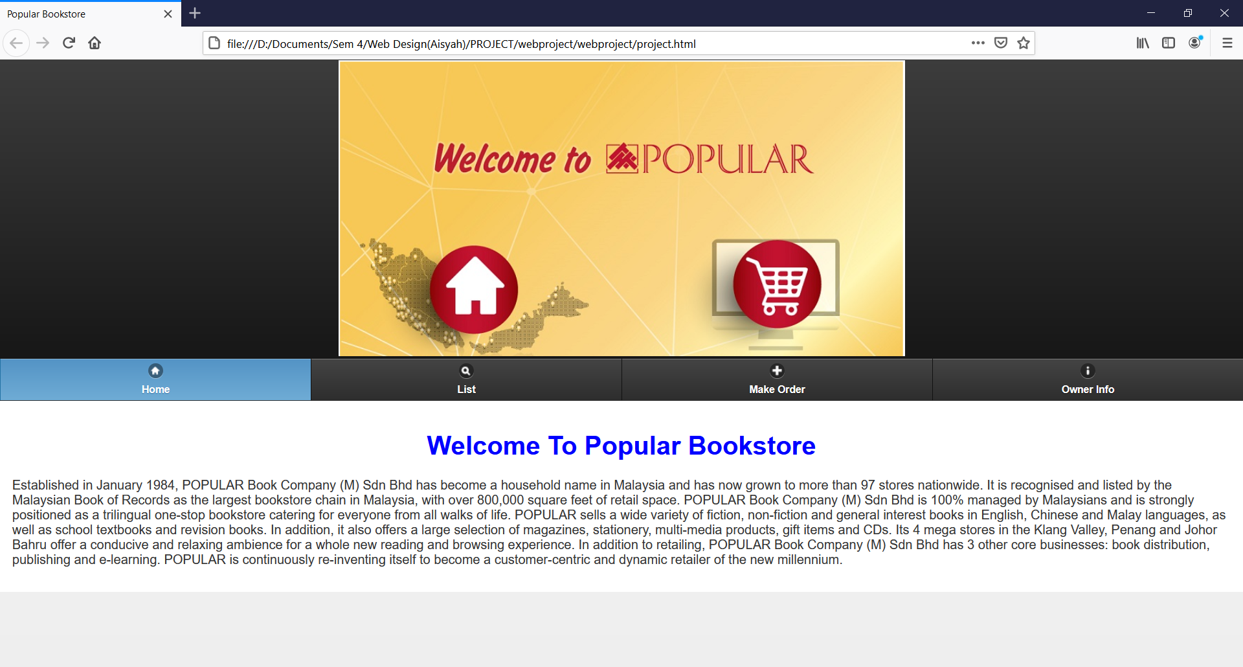

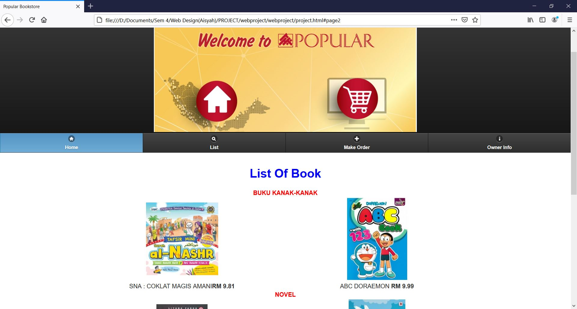

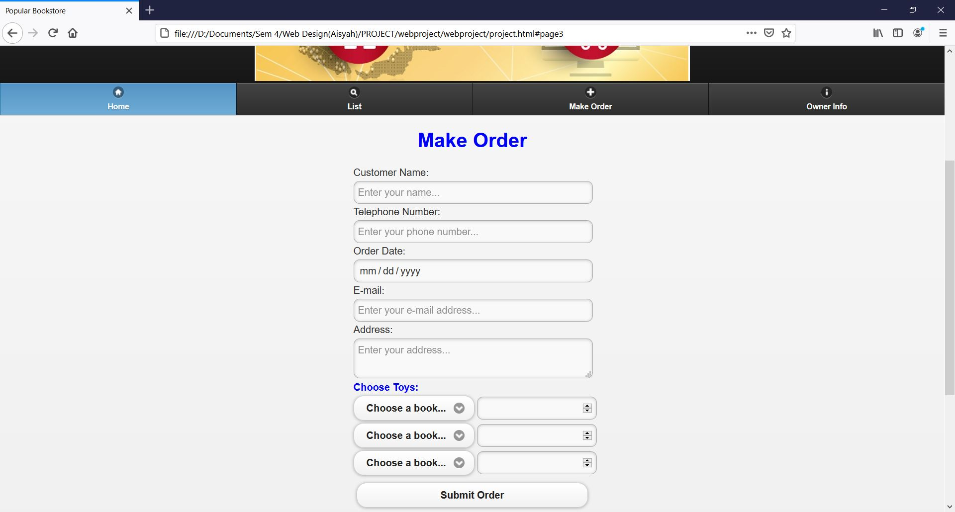

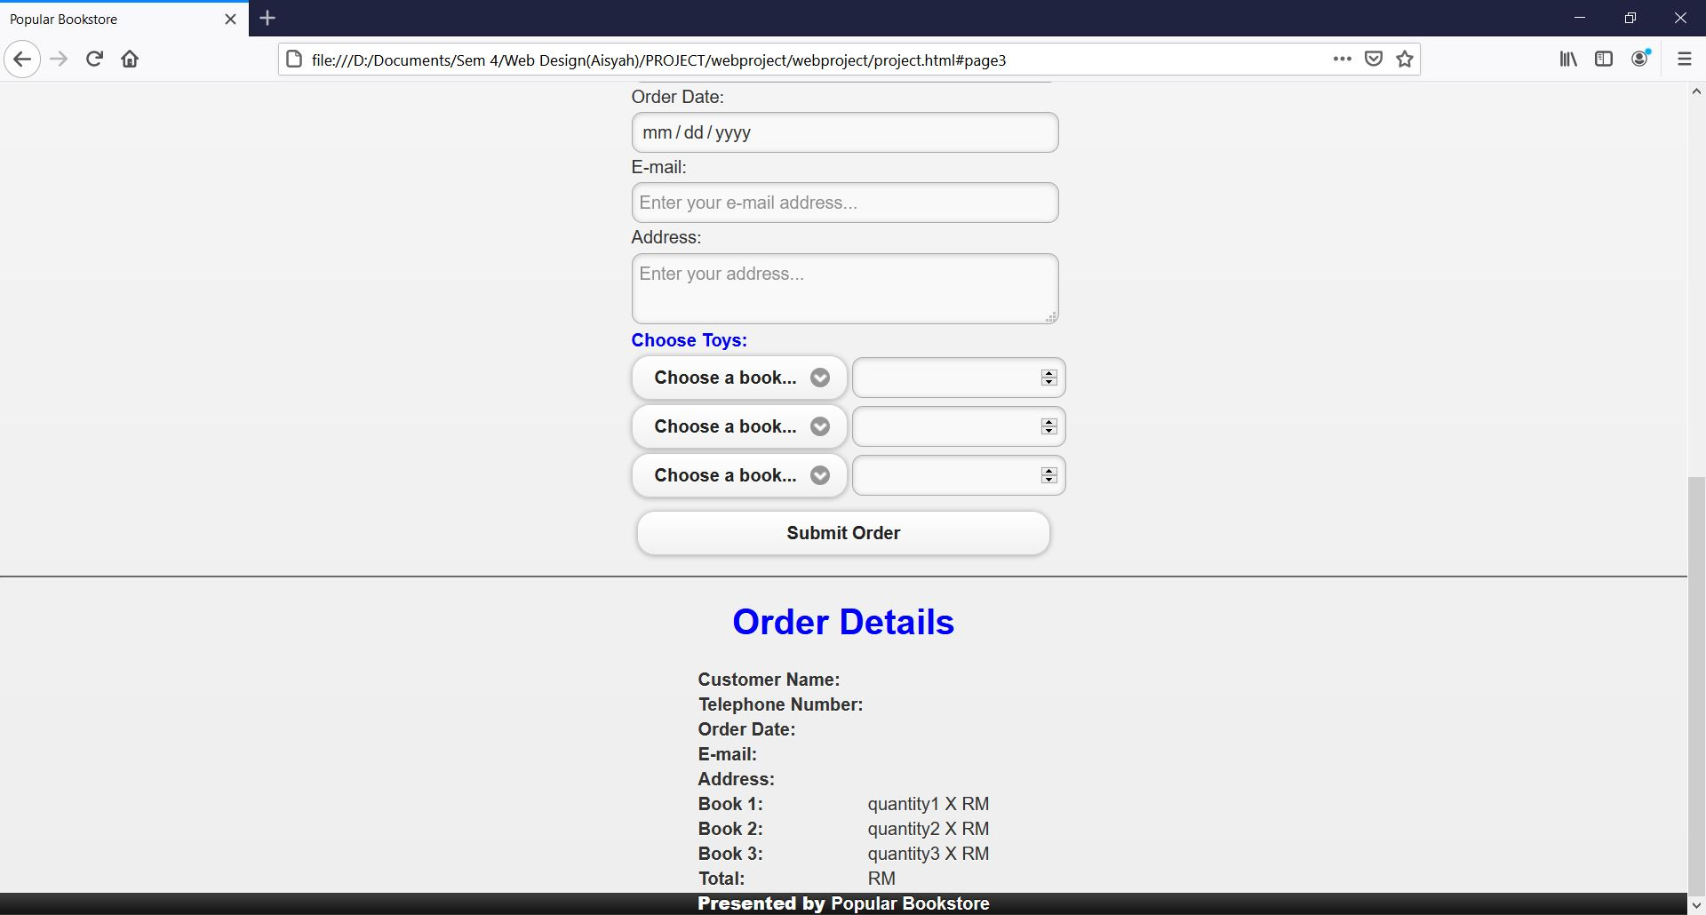

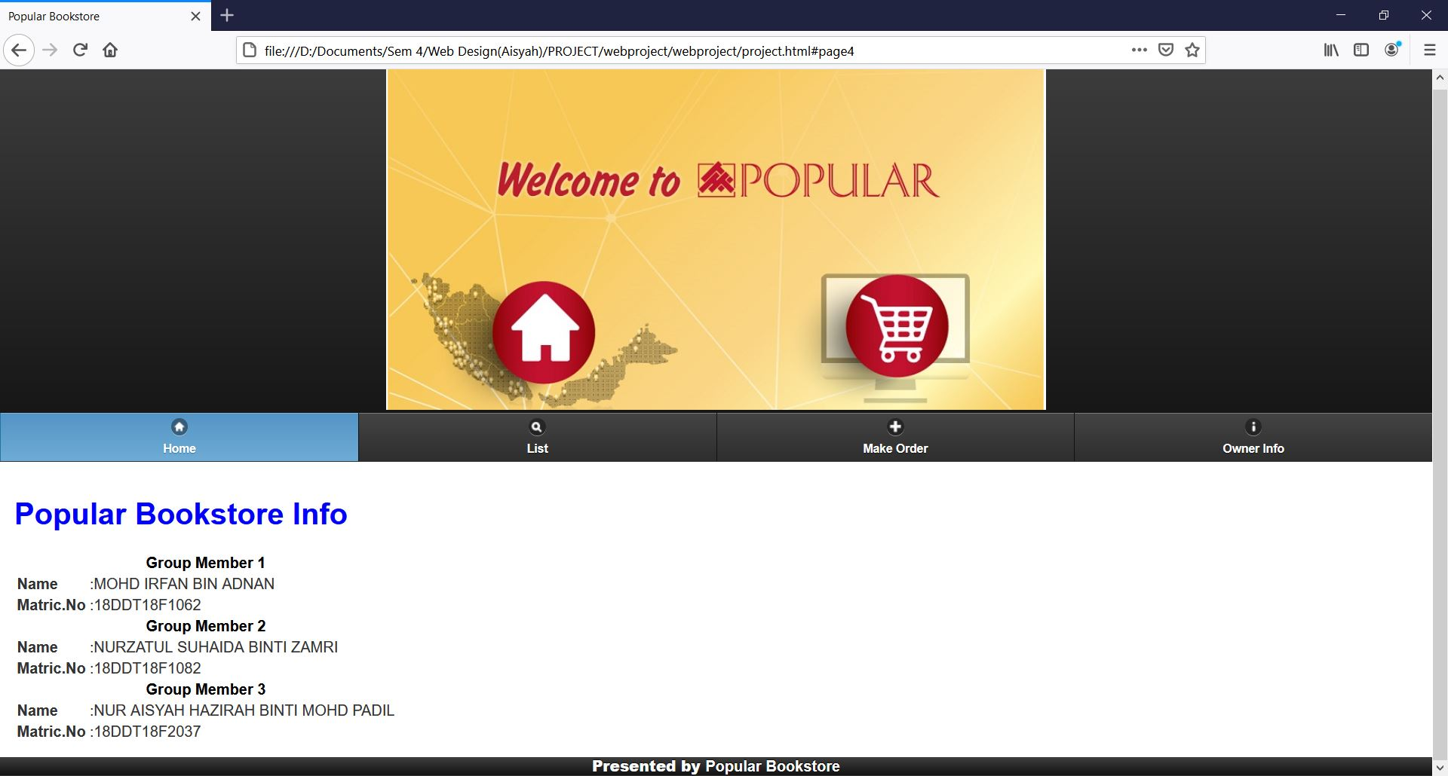

CODING

<!DOCTYPE html>

<html>

    <head>

        <meta charset="utf-8">

        <meta name="viewport" content="width=device-width, initial-scale=1">

        <link rel="stylesheet" type="text/css"  href="css/jquery.mobile.css">

        <script src="js/jquery.js"></script>

        <script src="js/jquery.mobile.js"></script>

        <script src="jquery-3.4.1.min.js"></script>

        <title>Popular Bookstore</title>

    </head>

    <body>

        <!-- Page 1 codes-->

        <div data-role="page" id="page1" data-add-back-btn="true" data-back-btn-theme="c" data-back-btn-text="Back">

            <div data-role="header">

                <center><img src="images/welcome to popular.PNG" width="700px"/></center>

                <div data-role="navbar">

                    <ul>

                        <li><a data-icon="home" href="#page1" class="ui-btn-active ui-state-persist" data-transition="flip">Home</a></li>

                        <li><a data-icon="search" href="#page2" data-transition="flip">List</a></li>

                        <li><a data-icon="right" href="#page3" data-transition="flip">Make Order</a></li>

                        <li><a data-icon="info" href="#page4" data-transition="flip">Owner Info</a></li>

                    </ul>

                </div>

            </div>

            <div data-role="content" data-theme="d">

            <center>

                <h1><font color="blue" >Welcome To Popular Bookstore</font></h1>

            </center>

                <p>

                    Established in January 1984, POPULAR Book Company (M) Sdn Bhd has become a household name in Malaysia and has now grown to more than 97 stores nationwide.

                    It is recognised and listed by the Malaysian Book of Records as the largest bookstore chain in Malaysia, with over 800,000 square feet of retail space.

                    POPULAR Book Company (M) Sdn Bhd is 100% managed by Malaysians and is strongly positioned as a trilingual one-stop bookstore catering for everyone from all walks of life.

                    POPULAR sells a wide variety of fiction, non-fiction and general interest books in English, Chinese and Malay languages, as well as school textbooks and revision books. In addition, it also offers a large selection of magazines, stationery, multi-media products, gift items and CDs.

                    Its 4 mega stores in the Klang Valley, Penang and Johor Bahru offer a conducive and relaxing ambience for a whole new reading and browsing experience.

                    In addition to retailing, POPULAR Book Company (M) Sdn Bhd has 3 other core businesses: book distribution, publishing and e-learning.

                    POPULAR is continuously re-inventing itself to become a customer-centric and dynamic retailer of the new millennium.

                </p>

            </div>

        </div>

        <!-- end of div page 1 -->

        <!-- Page 2 codes-->

        <div data-role="page" id="page2" data-add-back-btn="true" data-back-btn-theme="c" data-back-btn-text="Back">

            <div data-role="header">

                <center><img src="images/welcome to popular.PNG" width="700px"/></center>

                <div data-role="navbar">

                    <ul>

                        <li><a data-icon="home" href="#page1" class="ui-btn-active ui-state-persist" data-transition="flip">Home</a></li>

                        <li><a data-icon="search" href="#page2" data-transition="flip">List</a></li>

                        <li><a data-icon="right" href="#page3" data-transition="flip">Make Order</a></li>

                        <li><a data-icon="info" href="#page4" data-transition="flip">Owner Info</a></li>

                    </ul>

                </div>

            </div>

            <div data-role="content" data-theme="d">

                <center>

                    <h1><font color="blue">List Of Book</font></h1>

                    <table border=0>

                        <tr>

                            <td colspan="2" align="center"><font color="red"><b>BUKU KANAK-KANAK</b></font></td>

                        </tr>

                        <tr>

                            <td align="center"><img src="images/bukuKanak.jpg" width="40%"/></td>

                            <td align="center"><img src="images/buku kanak2.jpg" width="40%"/></td>

                        </tr>

                        <tr>

                            <td align="center">SNA : COKLAT MAGIS AMANI<b>RM 9.81</b></td>

                            <td align="center">ABC DORAEMON <b>RM 9.99</b></td>

                        </tr>

                        <tr>

                            <td colspan="2" align="center"><font color="red"><b>NOVEL</b></font></td>

                        </tr>

                        <tr>

                            <td align="center"><img src="images/novel1.jpg" width="40%"/></td>

                            <td align="center"><img src="images/novel 2.jpg" width="40%"/></td>

                        </tr>

                        <tr>

                            <td align="center">BIDADARI TERSALAH SYURGA <b>RM 27.00</b></td>

                            <td align="center">CINTA SENTIASA MENANG <b>RM 20.00</b></td>

                        </tr>

                        <tr>

                            <td colspan="2" align="center"><font color="red"><b>BUKU SEJARAH AGAMA</b></font></td>

                        </tr>

                        <tr>

                            <td align="center"><img src="images/bukuSejarahAgama1.jpg" width="40%"/></td>

                            <td align="center"><img src="images/BukuMuhamadbukanPendusta.jpg" width="40%"/></td>

                        </tr>

                        <tr>

                            <td align="center">MEMBONGKAR SEJARAH AGAMA & BUDAYA MELAYU <b>RM 38.90</b></td>

                            <td align="center">MUHAMMAD BUKAN PENDUSTA: MEMBONGKAR FITNAH DAN <b>RM 37.90</b></td>

                        </tr>

                    </table>

                </center>

            </div>

            <div data-role="footer">

                <center><b>Presented by </b>Popular Bookstore</center>

            </div>

        </div>

        <!-- end of div page 2 -->

        <!-- Page 3 codes -->

        <div data-role="page" id="page3" data-add-back-btn="true" data-back-btn-theme="c" data-back-btn-text="Back">

            <div data-role="header">

                <center><img src="images/welcome to popular.PNG" width="700px"/></center>

                <div data-role="navbar">

                    <ul>

                        <li><a data-icon="home" href="#page1" class="ui-btn-active ui-state-persist" data-transition="flip">Home</a></li>

                        <li><a data-icon="search" href="#page2" data-transition="flip">List</a></li>

                        <li><a data-icon="right" href="#page3" data-transition="flip">Make Order</a></li>

                        <li><a data-icon="info" href="#page4" data-transition="flip">Owner Info</a></li>

                    </ul>

                </div>

            </div>

            <div> <!-- To make order -->

                <center>

                    <h1><font color="blue">Make Order</font></h1>

                    <form name="Make Order" method="post" onsubmit="return calculateOrder();">

                        <table border="0">

                            <tr>

                                <td colspan="2">Customer Name:</td>

                            </tr>

                            <tr>

                                <td colspan="2"><input type="text" name="custName" placeholder="Enter your name..." required/></td>

                            </tr>

                            <tr>

                                <td colspan="2">Telephone Number:</td>

                            </tr>

                            <tr>

                                <td colspan="2"><input type="text" name="custNum" placeholder="Enter your phone number..." required/></td>

                            </tr>

                            <tr>

                                <td colspan="2">Order Date:</td>

                            </tr>

                            <tr>

                                <td colspan="2"><input type="date" name="custDate" required/></td>

                            </tr>

                            <tr>

                                <td colspan="2">E-mail:</td>

                            </tr>

                            <tr>

                                <td colspan="2"><input type="email" name="custEmail" placeholder="Enter your e-mail address..." required/></td>

                            </tr>

                            <tr>

                                <td colspan="2">Address:</td>

                            </tr>

                            <tr>

                                <td colspan="2"><textarea name="custAddress" placeholder="Enter your address..." required></textarea></td>

                            </tr>

                            <tr>

                                <td colspan="2"><font color="blue"><b>Choose Toys:</b></font></td>

                            </tr>

                            <tr>

                                <td><select name="order1"required>

                                    <option value="">Choose a book...</option>

                                    <option value="bs1">SNA : COKLAT MAGIS AMANI</option>

                                    <option value="bs2">ABC DORAEMON</option>

                                    <option value="hk1">BIDADARI TERSALAH SYURGA</option>

                                    <option value="hk2">CINTA SENTIASA MENANG</option>

                                    <option value="sw1">MEMBONGKAR SEJARAH AGAMA & BUDAYA MELAYU</option>

                                    <option value="sw2">MUHAMMAD BUKAN PENDUSTA: MEMBONGKAR FITNAH DAN</option>

                                </select></td>

                                <td><input type="number" name="quantity1" required/></td>

                            </tr>

                            <tr>

                                <td><select name="order2"required>

                                    <option value="">Choose a book...</option>

                                    <option value="bs1">SNA : COKLAT MAGIS AMANI</option>

                                    <option value="bs2">ABC DORAEMON</option>

                                    <option value="hk1">BIDADARI TERSALAH SYURGA</option>

                                    <option value="hk2">CINTA SENTIASA MENANG</option>

                                    <option value="sw1">MEMBONGKAR SEJARAH AGAMA & BUDAYA MELAYU</option>

                                    <option value="sw2">MUHAMMAD BUKAN PENDUSTA: MEMBONGKAR FITNAH DAN</option>

                                </select></td>

                                <td><input type="number" name="quantity2" required/></td>

                            </tr>

                            <tr>

                                <td><select name="order3"required>

                                    <option value="">Choose a book...</option>

                                    <option value="bs1">SNA : COKLAT MAGIS AMANI</option>

                                    <option value="bs2">ABC DORAEMON</option>

                                    <option value="hk1">BIDADARI TERSALAH SYURGA</option>

                                    <option value="hk2">CINTA SENTIASA MENANG</option>

                                    <option value="sw1">MEMBONGKAR SEJARAH AGAMA & BUDAYA MELAYU</option>

                                    <option value="sw2">MUHAMMAD BUKAN PENDUSTA: MEMBONGKAR FITNAH DAN</option>

                                </select></td>

                                <td><input type="number" name="quantity3" required/></td>

                            </tr>

                            <tr>

                                <td colspan="2"><input type="submit" value="Submit Order"/></td>

                            </tr>

                        </table>

                    </form>

                </center>

            </div>

            <hr>

            <div> <!-- To summarize order -->

                <center>

                    <h1><font color="blue">Order Details</font></h1>

                    <table border="0">

                        <tr>

                            <td><b>Customer Name:</b></td>

                            <td><div id=disCustName></div></td>

                        </tr>

                        <tr>

                            <td><b>Telephone Number:</b></td>

                            <td><div id=disCustNum></div></td>

                        </tr>

                        <tr>

                            <td><b>Order Date:</b></td>

                            <td><div id=disCustDate></div></td>

                        </tr>

                        <tr>

                            <td><b>E-mail:</b></td>

                            <td><div id=disCustEmail></div></td>

                        </tr>

                        <tr>

                            <td><b>Address:</b></td>

                            <td><div id=disCustAddress></div></td>

                        </tr>

                        <tr>

                            <td><b>Book 1:</b></td>

                            <td><div id="disQuantity1"></div> quantity1 X RM<div id="disPrice1"></div> <div id=disOrder1></div></td>

                        </tr>

                        <tr>

                            <td><b>Book 2:</b></td>

                            <td><div id="disQuantity2"></div> quantity2 X RM<div id="disPrice2"></div> <div id=disOrder2></div></td>

                        </tr>

                        <tr>

                            <td><b>Book 3:</b></td>

                            <td><div id="disQuantity3"></div> quantity3 X RM<div id="disPrice3"></div> <div id=disOrder3></div></td>

                        </tr>

                        <tr>

                            <td><b>Total:</b></td>

                            <td>RM<div id="disTotal"></div></td>

                        </tr>

                    </table>

                </center>

            </div>

            <script>

                function calculateOrder()

                {

                    var name = document.getElementById("custName").value;

                    var number = Number(document.getElementById("custNum").value);

                    var date = document.getElementById("custDate").value;

                    var email = document.getElementById("custEmail").value;

                    var address = document.getElementById("custAddress").value;

                    var order1 = document.getElementById("order1").value;

                    var quantity1 = Number(document.getElementById("quantity1").value);

                    var disOrder1 = checkOrder(order1);

                    var price1 = checkPrice(order1);

                    var order2 = document.getElementById("order2").value;

                    var quantity2 = Number(document.getElementById("quantity2").value);

                    var disOrder2 = checkOrder(order2);

                    var price2 = checkPrice(order2);

                    var order3 = document.getElementById("order3").value;

                    var quantity3 = Number(document.getElementById("quantity3").value);

                    var disOrder3 = checkOrder(order3);

                    var price3 = checkPrice(order3);

                    var total = (price1 * quantity1) + (price2 * quantity2) + (price3 * quantity3);

                    document.getElementById("disCustName").innerHTML = name;

                    document.getElementById("disCustNum").innerHTML = number;

                    document.getElementById("disCustDate").innerHTML = date;

                    document.getElementById("disCustEmail").innerHTML = email;

                    document.getElementById("disCustAddress").innerHTML = address;

                    document.getElementById("disQuantity1").innerHTML = quantity1;

                    document.getElementById("disPrice1").innerHTML = price1.toFixed(2);

                    document.getElementById("disOrder1").innerHTML = disOrder1;

                    document.getElementById("disQuantity2").innerHTML = quantity2;

                    document.getElementById("disPrice2").innerHTML = price2.toFixed(2);

                    document.getElementById("disOrder2").innerHTML = disOrder2;

                    document.getElementById("disQuantity3").innerHTML = quantity3;

                    document.getElementById("disPrice3").innerHTML = price3.toFixed(2);

                    document.getElementById("disOrder3").innerHTML = disOrder3;

                    document.getElementById("disTotal").innerHTML = total.toFixed(2);

                    return false;

                }

                function checkPrice(price)

                {

                    if(grade=="bs1")

                        return 4.00

                    else if(grade=="bs2")

                        return 4.00

                    else if(grade=="hk1")

                        return 3.67

                    else if(grade=="hk2")

                        return 3.33

                    else if(grade=="sw1")

                        return 3.00

                    else if(grade=="sw2")

                        return 2.67

                    else

                        return 0.00

                }

                function checkOrder(order)

                {

                    if(grade=="bs1")

                        return "Barbie Set 1"

                    else if(grade=="bs2")

                        return "Barbie Set 2"

                    else if(grade=="hk1")

                        return "LEGO Hello Kitty Set 1"

                    else if(grade=="hk2")

                        return "LEGO Hello Kitty Set 2"

                    else if(grade=="sw1")

                        return "LEGO StarWars Set 1"

                    else if(grade=="sw2")

                        return "LEGO StarWars Set 2"

                    else

                        return "None"

                }

            </script>

            <div data-role="footer">

                <center><b>Presented by </b>Popular Bookstore</center>

            </div>

        </div>

        <!-- end of div page 3 -->

        <!-- Page 4 codes-->

        <div data-role="page" id="page4" data-add-back-btn="true" data-back-btn-theme="c" data-back-btn-text="Back">

            <div data-role="header">

                <center><img src="images/welcome to popular.PNG" width="700px"/></center>

                <div data-role="navbar">

                    <ul>

                        <li><a data-icon="home" href="#page1" class="ui-btn-active ui-state-persist" data-transition="flip">Home</a></li>

                        <li><a data-icon="search" href="#page2" data-transition="flip">List</a></li>

                        <li><a data-icon="right" href="#page3" data-transition="flip">Make Order</a></li>

                        <li><a data-icon="info" href="#page4" data-transition="flip">Owner Info</a></li>

                    </ul>

                </div>

            </div>

            <div data-role="content" data-theme="d">

                    <table border=0>

                    <h1><font color="blue">Popular Bookstore Info</font></h1>

                    <tr>

                    <td colspan="2" align="center"><font color="black"><b>Group Member 1<b></font></td>

                    </tr>

                    <tr>

                        <td><b>Name</b></td><!--column 2--->

                        <td>:MOHD IRFAN BIN ADNAN<br></td>

                    </tr>

                    <tr>

                        <td><b>Matric.No</b></td><!--column 2--->

                        <td>:18DDT18F1062<br></td>

                    </tr>

                    <tr>

                    <td colspan="2" align="center"><font color="black"><b>Group Member 2<b></font></td>

                    </tr>

                    <tr>

                        <td><b>Name</b></td><!--column 2--->

                        <td>:NURZATUL SUHAIDA BINTI ZAMRI<br></td>

                    </tr>

                    <tr>

                        <td><b>Matric.No</b></td><!--column 2--->

                        <td>:18DDT18F1082<br></td>

                    </tr>

                        <tr>

                    <td colspan="2" align="center"><font color="black"><b>Group Member 3<b></font></td>

                    </tr>

                    <tr>

                        <td><b>Name</b></td><!--column 2--->

                        <td>:NUR AISYAH HAZIRAH BINTI MOHD PADIL<br></td>

                    </tr>

                    <tr>

                        <td><b>Matric.No</b></td><!--column 2--->

                        <td>:18DDT18F2037<br></td>

                    </tr>

                    </table>

            </div>

            <div data-role="footer">

                <center><b>Presented by </b>Popular Bookstore</center>

            <!-- end of div page 4 -->

    </body>

</html>

EXPLAINATION

URL

1. **git**

https://github.com/

1. **Website**

http://